What caused the tsunami?
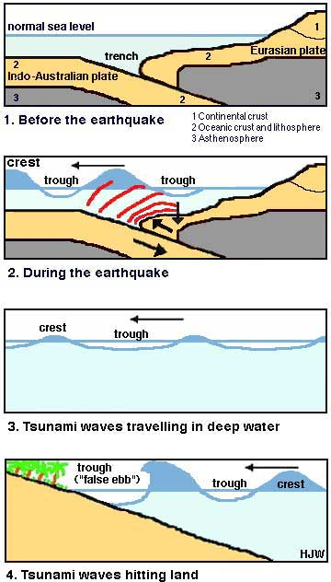
Though thankfully rare, there are many phenomena that can cause tsunamis: volcanic eruptions, landslides, collapsing icebergs, and earthquakes. The December 26, 2004 tsunami was caused by a vast earthquake: the second-largest in history, with a force that has recently been upgraded to 9.3 on the Richter Scale.

Most earthquakes occur when tectonic plates - the huge, slowly moving plates on which the earth’s continents rest - slide against each other. Sliding earthquakes, though potentially devastating on land, do not usually cause tsunamis. ‘Shear events’, where one tectonic plate moves upwards sharply against another, can cause tsunamis.

On December 26, 2004, at 7.55 am, the edge of the India Plate lifted suddenly against the Burma Plate, near the Simeulue Islands off the coast of Acheh, Sumatra, Indonesia. One side of a crack along the sea bed was lifted upwards – in some places as high as 15 metres (50 feet). This released as much energy as 30,000 Hiroshima atom bombs going off simultaneously.
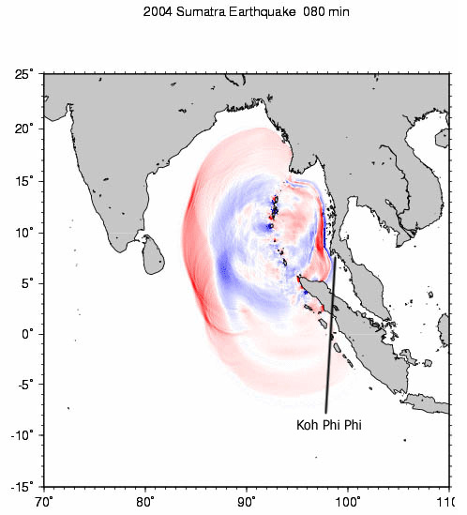
Next time you are in a bath or a swimming pool, put your hand under the surface of the water and push it up sharply. Watch how the water reacts. Then multiply the effect by several billion. The waves traveled in a similar fashion to the ripples caused by a pebble dropped in a pond, except the ‘ripples’ were up to 35 metres (100 feet) high, many kilometres (miles) long, and traveled at speeds of up to 800 km/h (500 mph).

When it is passing through deep water, a tsunami is hardly noticeable to anyone on the surface. However, when it hits land, the wave decreases in speed, which means the energy in the wave causes it to gain height.

Often, before tsunamis hit land, they are preceded by a ‘false ebb’. This causes the sea level to drop dramatically before the water returns at a much higher level.

Wind-generated waves can reach heights similar to those of tsunamis. The difference, however, is that the length of a wind-generated wave is only a few metres (yards); a tsunami can have a wavelength many kilometers (miles) long. The effect on land is a temporary raising and lowering of the sea level, sometimes repeated many times. The water that surges onto the land is gigantic in volume, which explains the appalling destructiveness of a tsunami.

